“Endo Peace” Functional Powder Spray System (Sterile)
MOHW-MD-No. 008448

Please read the original user manual carefully before operating this device and follow all guidelines accordingly.

INTENDED USE
The Functional Powder Spray System (FP Spray) is a single-use delivery device designed for gastrointestinal endoscopic procedures. It is recommended for use with powder-based products with a particle size <250 µm and moisture content <10%.
NOTES
- Do not use this product for any purposes other than the intended use mentioned above.
- This product is intended for use only by physicians and technicians proficient in endoscopic procedures.
DEVICE DESCRIPTION
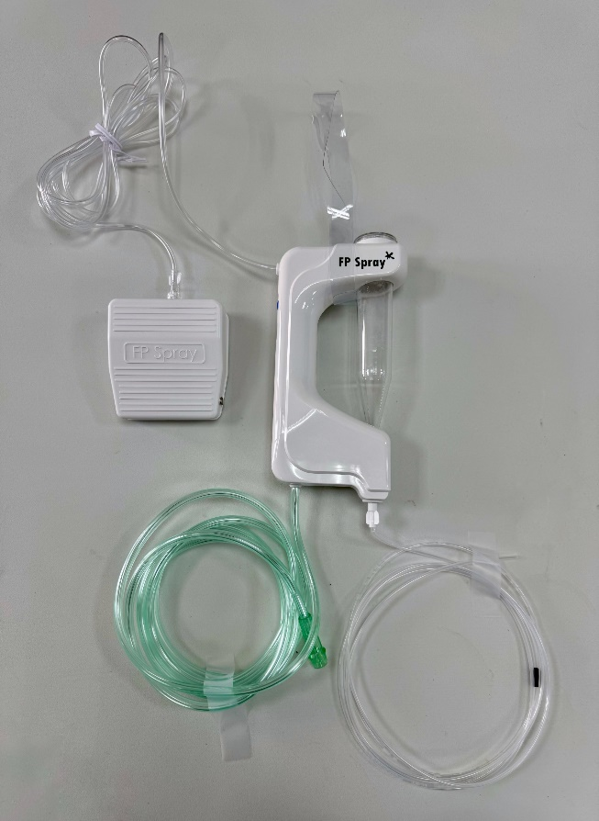
Warning sign
Taylor Cone
Strap
LDPE Catheter
Nasal Canula
Foot Pedal
PVC tube
FP Spray is a single-use device designed to deliver powder through the central medical gas supply of healthcare facilities or an external CO₂ cylinder. The catheter is inserted into the gastrointestinal tract via the working channel of the endoscope. Once the gas source is set up, the powder can be precisely delivered to the targeted lesion by simply operating the foot pedal, achieving the desired therapeutic effect.
OPERATING INSTRUCTIONS
Product Verification | Step 1 | Step 2
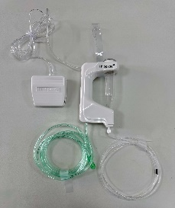 | 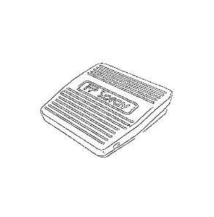 |   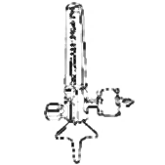
Check the packaging integrity first. If any abnormalities are found after removing from the package, do not use. | Place the foot pedal in an accessible position for easy use. | Connect the oxygen nasal cannula to the medical gas outlet or an external CO₂ cylinder.
Step 3 | Step 4 | Step 5
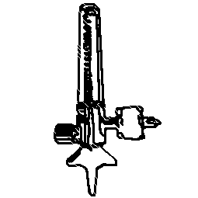   | 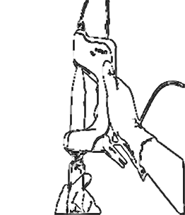   | 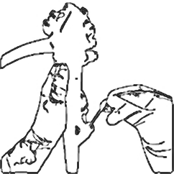  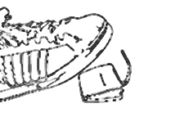
Open the flow valve and set the airflow between 1 to 3 LPM. If using a CO₂ cylinder, adjust the pressure valve to 10 to 15 psi. | Install the powder bottle onto the spraying system, ensuring it is securely locked. Keep the system flat or inverted (avoid hanging) to prevent powder clumping. | Press the foot pedal while inserting the LDPE catheter into the endoscope working channel until visible (do not exceed the warning sign), then release the foot pedal. Keep the catheter tip 1-2 cm from the lesion for spraying.  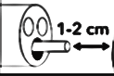
Step 6 | Step 7 | Step 8
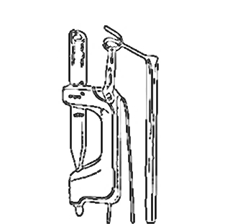 | 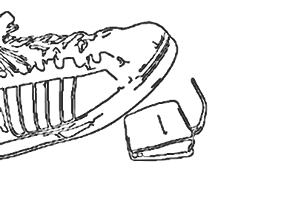 | 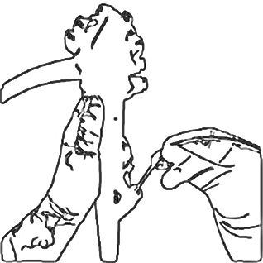
Hang the device at an elevated position. | Pressing the foot pedal allows the powder to be sprayed in a single dose or in segments. | After use, close the flow valve and remove the catheter from the endoscope working channel.

CONTRAINDICATIONS
The use of this device is contraindicated in patients with suspected gastrointestinal perforation or those at high risk of gastrointestinal perforation during endoscopic procedures.

WARNING
- Keep the catheter tip 1-2 cm away from the bleeding site to minimize the risk of blockage.
- This device is intended for single use only. Reuse or re-sterilization may lead to device malfunction or disease transmission.
- Prior to use, inspect the packaging for integrity and ensure that the catheter is free of twists, kinks, or damage. If any condition is found that may compromise functionality, do not use the device. Retain the affected product and contact Endo Peace Biomedical Technology Co., Ltd. or its authorized distributor for return processing. If a malfunction occurs during the procedure, do not attempt to repair the device. Replace it with a backup unit and notify the company for retrieval.
- The device must be used dry. Contact with liquids (e.g., blood, body fluids, saline) before or during powder spraying may interfere with proper spraying.

PRECAUTIONS
- If any issues arise that affect the spraying process, close the flow valve, remove the catheter from the endoscope working channel, and place the spraying system flat to prevent powder leakage. Replace the catheter and repeat steps 3 to 7.
- Any opened or unused product must be discarded. Do not reuse or re-sterilize.

PRODUCT MODEL
Model Number | LDPE Catheter Length (cm) | LDPE Catheter Inner/Outer Diameter (mm) | Minimum Endoscope Working Channel Diameter (mm)
ST-01-112 | 220 | 1.8/2.5 | 2.8

MANUFACTURER AND MEDICAL DEVICE DISTRIBUTOR INFORMATION
Medical Device Distributor Name: Endo Peace Biomedical Technology CO., LTD.
Medical Device Distributor Address: Room. A10, 4th Floor., Technology Building, Tzu-Chiang Campus, No. 1, Daxue Rd., East Dist., Tainan City 701, Taiwan.
Manufacturer Name: Pacific Hospital Supply Co., Ltd., Science Park Plant, commissioned by Endo Peace Biomedical Technology CO., LTD.
Manufacturer Address: No. 8, Tongke 2nd Road, Tongluo Township, Miaoli 366, Taiwan.

